**How many times did Bike It schools go to Lapland**

**and back from Peterborough**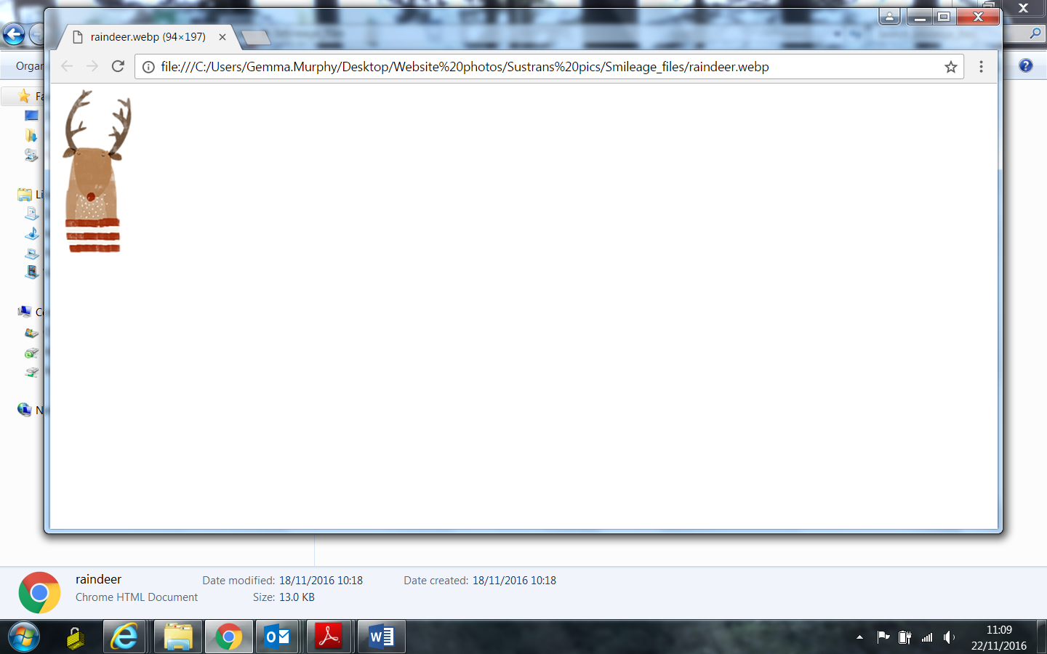[](http://www.clipartpanda.com/categories/christmas-tree-clip-art-free)**?**

**St Thomas More = 3.41**

Gladstone = 3.02

**Middleton = 3.01**

**Beeches = 2.04**

Ravensthorpe = 1.50

Queens Drive Infants = 1.47

St.Augustine’s =1.35

[](http://www.google.co.uk/url?sa=i&rct=j&q=&esrc=s&source=images&cd=&cad=rja&uact=8&ved=&url=http://www.zazzle.com/santa%2Bornaments&bvm=bv.131783435,d.ZGg&psig=AFQjCNEQqlI6jsJVZzHCI36jXzOmE3QGhA&ust=1473169238668791)